**EEE 6512 Image Processing & Computer Vision**

**Assignment 02**

**Name: Chen Yang Username: cyang3 UF id: 52109967**

2.4

The tree cones are L-cones, M-cones and S-cones, which are respectively sensitive to light with long wavelength, medium wavelength and short wavelength.[1]

2.9

scotopic vision —— starlight

photopic vision —— sunlight

mesopic vision —— moonlight[1]

2.10

No, in daily well-lighted situations, rods are not functional because under such condition they will become saturated and stop working. It will take for a while for those cones cells to become available again and restore normal vision.

2.22

Geometrically, an ideal pinhole camera consists of a point called focal point (a pinhole through which all rays of light pass), and a plane called image plain (the sensor surfaces on with the image is formed).[1]

2.24

Radio waves has the longer wavelength. X-rays is more dangerous. Because the greater the frequency is, the lower the wavelength will be. Besides, the energy of rays is proportional to its frequency. So, X-rays has the shorter wavelength than radio waves, which represents that X-rays has more energy. To sum up, X-rays is more dangerous.[1]

3.5

Representing those computation in 8 bits means the values in the output should in the range of [0,255]; Therefore,

(8 bit computation)

52+200 = 252 → 252

86+199 = 255 → 255

30-50 = -20 < 0 → 0 （out of lower bound）

32+11 = 43 → 43

Representing those computation in 4 bits means the output values should be in the range of [0,15]; Therefore,

(4 bit computation)

52+255 = 252 > 15 → 15 (out of upper bound)

89+199 = 255 > 15 → 15 (out of upper bound)

30-50 = -20 < 0 → 0 (out of lower bound)

32 + 11 = 43 > 15 →15 (out of upper bound)

3.7

The saturated value in the computation process will be highlighted.

I1= I2 =

1. sum = I1 + I2

= +

=

= =

1. difference = I1 - I2

= =

C) absolute difference = | I1 - I2 |

=

=

=

3.8

According to the equation 3.20 in the book :

In this problem, the gmax = 0.986 and gmin = 0.080, so gmax - gmin = 0.986-0.08 = 0.906. Therefore, the matrix after mapping is : Round =

3.12

Original image: bit plane 7: bit plane 4:

3.13

Original image:

1. histogram = [1 2 1 3 1 1 1 2 2 2]
2. normalized histogram =[0.0625 0.125 0.0625 0.1875 0.0625 0.0625 0.0625 0.125 0.125 0.125]
3. Cumulative normalized histogram = [0.0625 0.1875 0.25 0.4375 0.5 0.5625 0.625 0.75 0.875 1]

**Code Section for Assignment 02**

**The test results of function *myhist* are shown as follows:**

**out = myhist('gramStainPos.png');**

1. 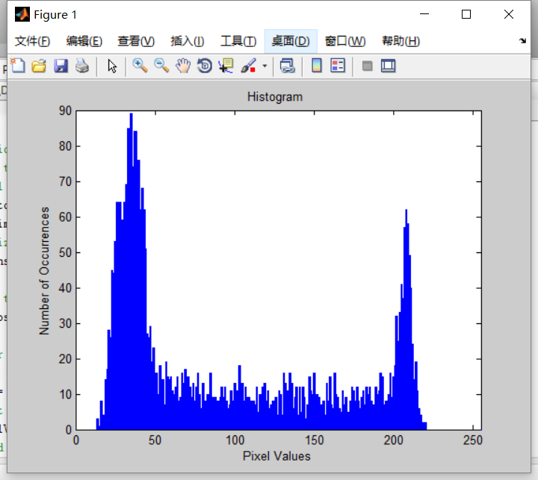We can easily find that in the distribution of the first histogram, there are two peaks, and the first greater peak is concentrated in the interval of pixel value 30-50. The positive cells are particularly dense in these areas, which means that the positive cells like to live in a darker environment. The second peak has a smaller pixel value range, and the number of occurrences of bacteria is smaller than that of the first peak, so we treat the second one as a noise signal.

**out = myhist('gramStainNeg.png');**

1. 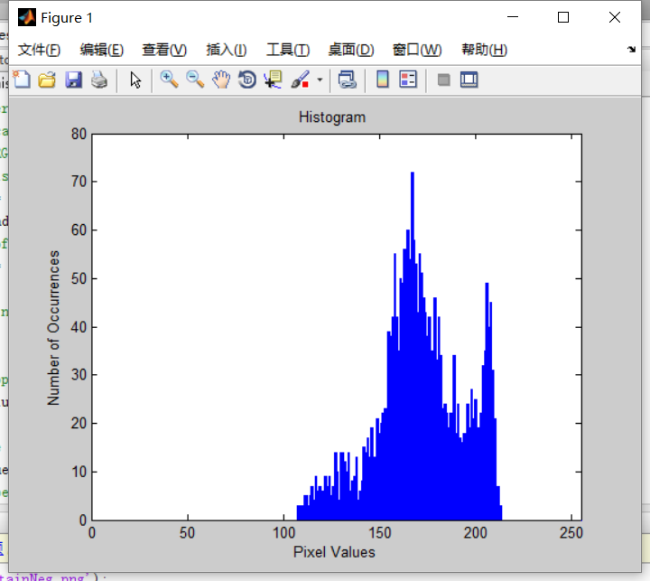We can easily find that there is only one obvious peak in this histogram. There are no negative bacteria in the area where the pixel value is less than 100, and a large number of negative bacteria accumulate in the range of the pixel value from 150 to 200. So we can conclude that stealth bacteria like to live in places with sufficient light.

**out = myhist('gramStainMix.png');**

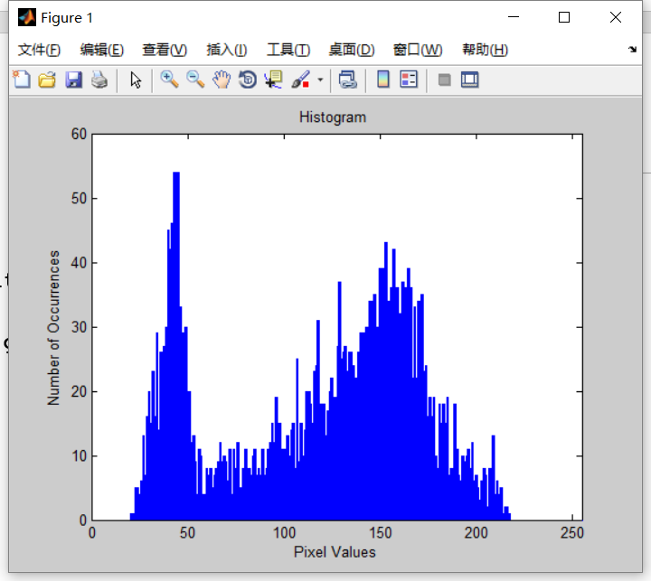

1. In this mix histogram, we found two peaks. These two peaks correspond to the habitable lighting conditions of positive bacteria and positive bacteria in the previous two histograms. In addition, we can also find that basically no bacteria survive in areas with pixel values ​​less than 25 and pixel values ​​greater than 225, which shows that neither positive bacteria nor invisible bacteria can survive in extreme conditions without light or strong light.

**The test results of function *myquantize* are shown as follows:**

**output = myquantize(imread('avengers.png'),2);**

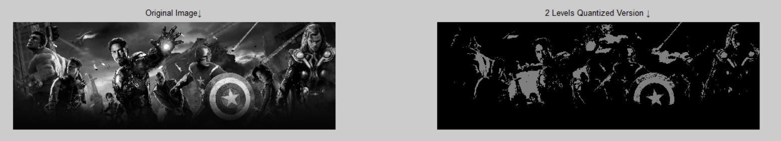

**output = myquantize(imread('avengers.png'),4);**

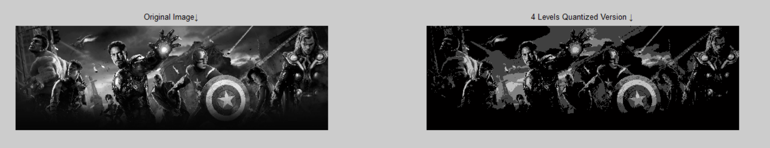

**output = myquantize(imread('avengers.png'),8);**

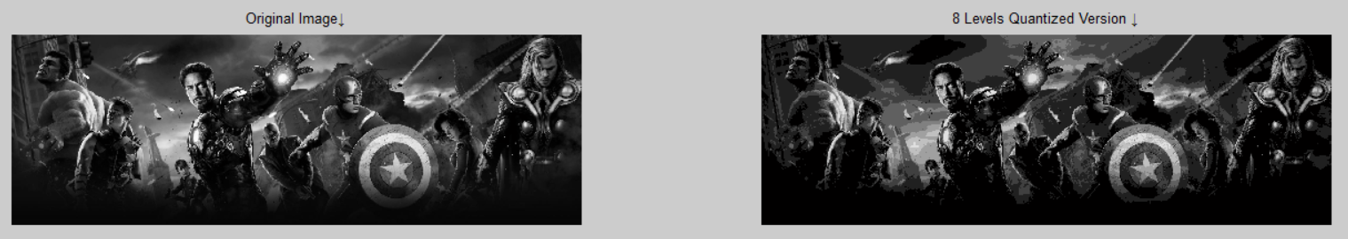

**output = myquantize(imread('avengers.png'),32);**

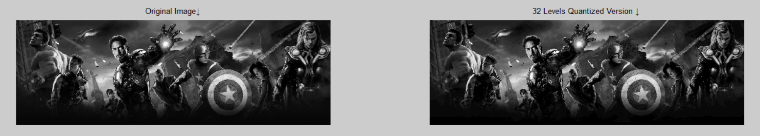

**output = myquantize(imread('avengers.png'),128);**



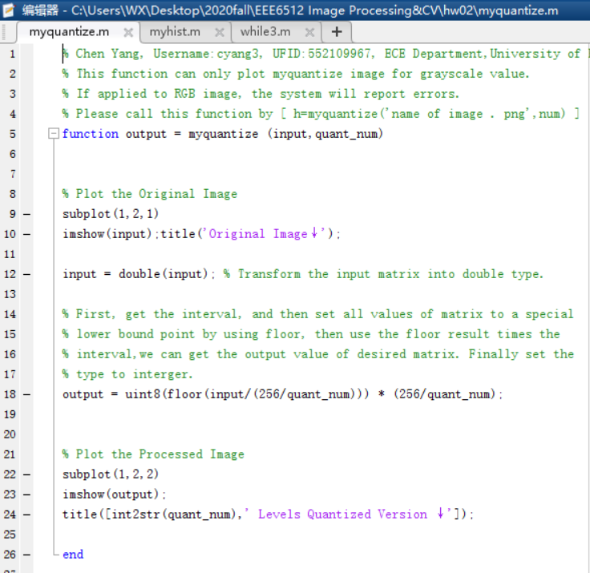

**Provide a detailed explanation of how your algorithm works.**

This algorithm will accept the intensty image and a quant_num as input. First, we will print an original image as preparation. Next, we divided each pixel by the factor of interval (256/quant_num) .In this process, We will know which interval each value corresponds to by using floor and division operations . Finally, in order to show the processed image, we need to use the interval (that each pixel belongs to) times interval length to get the output image.

The final output of this function is a comparison of the two images.

**Reference**

[1] B. H. Brown, R. H. Smallwood, D. C. Barber, P. V Lawford, and D. R. Hose, *Image processing and analysis*. 2004.